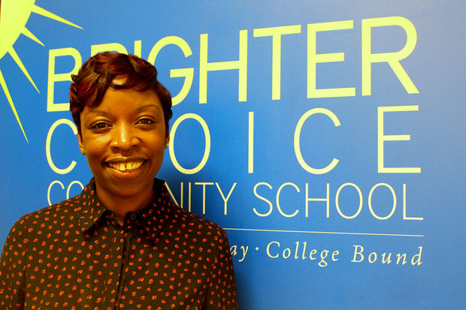

Name: Fabayo McIntosh Gordon

Principal Bio
Principal McIntosh-Gordon a graduate of both Lincoln University and Bank Street College she is a visionary education leader and devoted and experienced principal, who always dreamt of starting a school providing quality education for her native Bedford Stuyvesant community. Mrs. Gordon’s dream was realized when she was accepted out of hundreds of other applicants into the New Leaders for New Schools Principal’s training program. Throughout the years, she has built a school driven on professionalism and hard work, creating a community of learners. Principal McIntosh-Gordon is a product of the community in which she serves, proving herself to be one of Bedford –Stuyvesant’s most valued assets.
Hopes for Leadership Collaborative Pilot_____________________
Principal McIntosh-Gordon hopes that the District 16 Leadership Collaborative Pilot becomes a program that goes further than District 16. With effective professional learning that helps develop leadership capacity, she is convinced that the impact will be large on student growth in schools. All school leaders should have an opportunity to participate in such a phenomenal experience for leadership development.

Leadership Strengths
Principal McIntosh-Gordon is a visionary leader that talks and walks the school's vision. Her actions consistently align with it. She has a plan for how to implement this vision and every day takes actions towards leading all stakeholders towards this vision. She also is a community builder, knowing that she cannot implement the school's vision alone. She cultivates a range of partnerships particularly with parents, business and the community to support student learning and progress.

Signature Themes – StrengthsFinder 2.0
- Achiever 2.Relator 3.Arranger 4.Harmony 5.Positivity

Goals for 2016-2017

The goals Principal McIntosh-Gordon has for her school are to be District 16’s first dual language and STEAM school. She wants to have a robotics lab, a science lab, and students are working on a coding program. Her philosophy is that the world is changing around us. If we really want children to be prepared and have that foundation that they can build on later on, we have to adapt to what’s going on in the world right now. She also wants to grow the dual language program to be more than just Spanish. Language exposure to everyone is a long-term goal she is committed to.

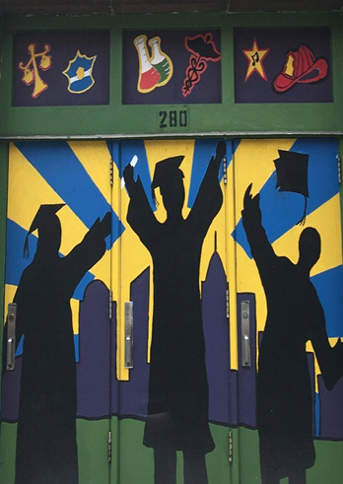

16K627- Brighter Choice Community School

School Description
Brighter Choice Community is a rigorous learning community where education is embedded in meaningful real-world contexts and children are deliberately taught to see the connections between school and the world. Our students will meet or exceed the New York State standards and be prepared to excel in the 21st century by becoming independent thinkers and working productively within a diverse group of learners. At Brighter Choice, students learn to combine curiosity with appropriate application, which leads to deep understanding and the confidence to become who they want to be

